**QUICK START USER GUIDE TO LIBRARY MANAGEMENT PROJECT**

1)Search a Book - Allows the user to search any book using any combinations of Book id and/or Book Title and /or Book Author. 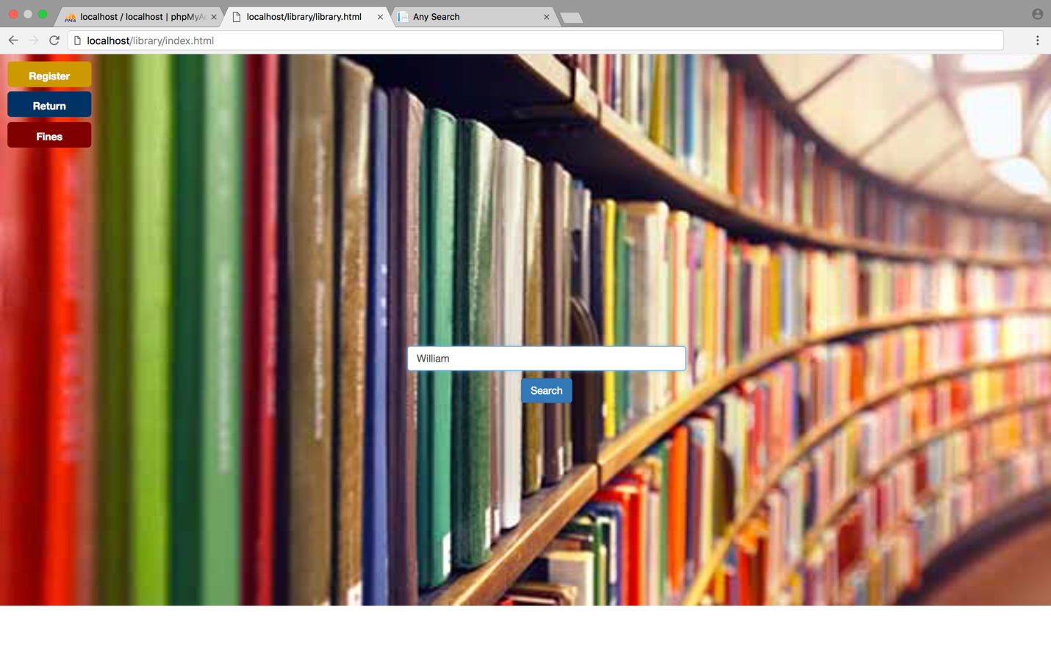

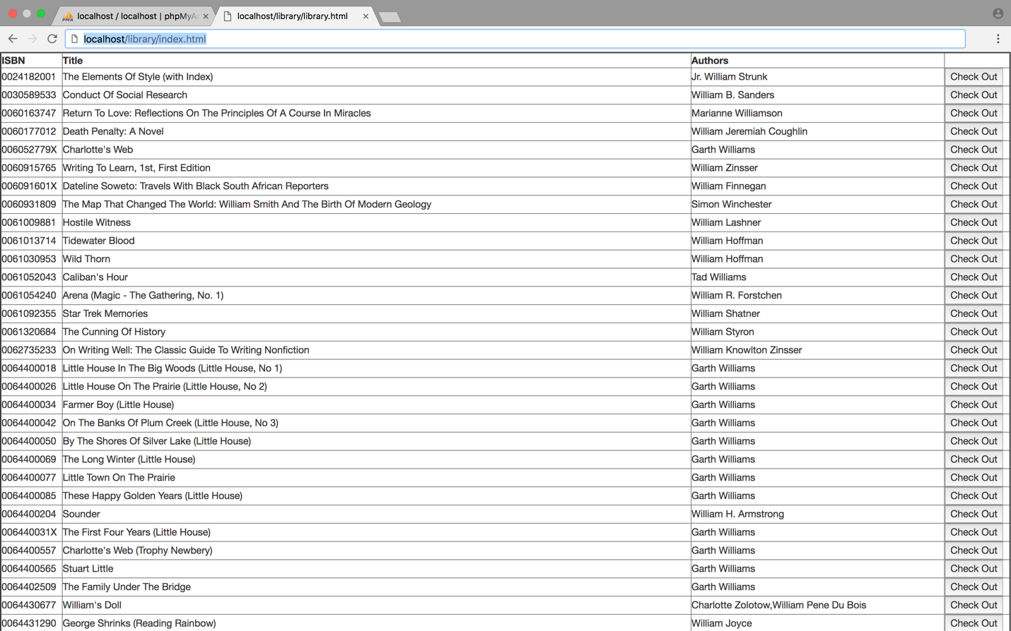

3)Check-in a Book - Allows a user to check-in the book. This feature first searches for all the book loans the borrower has taken which are not checked-in yet and then allows the user to check in the selected the book.



4)Register New Borrower - Allows the user to register a new borrower to the library loan system by specifying the SSN, name, address, and phone number.

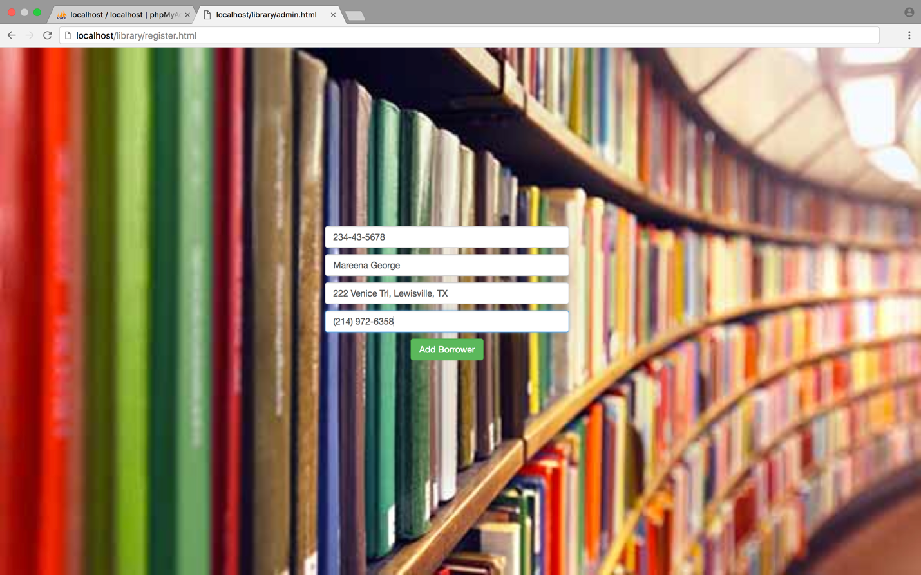

5)Fine - This feature allows two types of fine computation.



**Design Model**

Index.html is the Homepage where you can search, Register Borrowers, Update or Get Fine, Return Books

Book-return.html – Return books

Register.html -Create new borrower to the library loan system by specifying the SSN, name, address, and phone number.

Fine-mgmt.html-Get/Update fine by providing card number as the input.